Analysis and Severity Prediction of Vehicle Collisions in the US

Fawaz Akhtar

Problem

Each year in the United States, more than 700,000 vehicle collisions occur. This results in thousands of fatalities, as well as municipalities spending millions of dollars on the clean up roadways after a collision. In addition, collisions cost private corporations millions of dollars due to late employees, damaged company vehicles, loss to products destroyed during shipping collisions, and much more. Insurance companies, in particular, are at high risk due nature of their business. Each collision results in an inspector, an adjustor, and many support personnel to be deployed to ascertain the cause of the collision and to determine the cost to the company. These costs can be mitigated greatly if it is possible to predict the most likely place an accident is to occur and how severe the accident is likely to be.

Purpose and Potential Clients

The purpose of this project is to help various groups to mitigate costs related to vehicle collisions in various ways. For instance, local governments can use the information discovered to improve road safety by increasing signage and education regarding dangerous stretches of road. Private companies can divert their product transport routes to streets which are not as prone accidents; in effect, preventing profit loss by damaged goods during accidents involving transport trucks. Private citizens will be able to make more educated choices regarding safer routes around the local area, which will help reduce the cost of medical and vehicle repair bills resulting from collisions. This may also be beneficial to citizens in helping them reduce the financial stresses felt after a collision occurs.

Insurance companies are likely to be the most interested, however. By utilizing the findings of this study, they will be better able to control prices and possible costs in a specified area. For instance, customer retention could be increased by reducing prices in areas where there is low risk for severe collisions. On the other hand, costs could be reduced by increasing prices in areas where the risk of collisions is rather high. This would result in employee time being saved resulting in further reduction of costs for the company. Profits would, in effect, be maximized by reducing loss and other various costs.

Exploratory Data Analysis

In order to understand the data and find any trends it contained, the project began with the process of exploratory data analysis. The data was studied using several methods which revealed a number of interesting patterns contained within.

The first angle of study involved when collisions occurred. The data was collected over the course of four years; therefore, it was the first area of investigation.

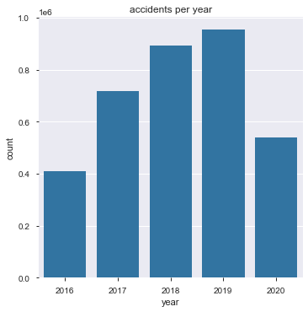

Fig 1. Accidents per year

To begin, it is important to note that the years 2016 and 2020 are both incomplete years. Data collection began in the middle of 2016 and ended in the middle of 2020. Therefore, it is important to not consider them when doing basic counts of accidents per year. However, it is more acceptable to consider them when discussing means and other statistical metrics.

In Figure 1, it becomes apparent that accidents have been increasing each year. Data collection ceased in June of 2020, but it appears that 2020 is well on its way to surpassing 2019. However, it should be noted, that because of the pandemic in 2020, it is possible that this trend will be broken. However, due to cultural norms in the United States, it is equally possible that travel is not impeded, and thus, accidents continue to increase in accordance to the trend seen. Further data will be required from 2020 and 2021 in order to definitively determine whether the trend of accidents increasing will continue through the pandemic. However, as of June of 2020, it appears that the pandemic has not affected the number of automobile collisions significantly. As seen in Figure 1, 2020 is well on its way to equaling and, eventually, surpassing the total accidents from 2019.

On the other hand, severity has decreased steadily in the same time period. As shown in Figure 2, there was a slight increase in 2017, but severity has been decreasing since then. In fact, starting in 2019, the severity has declined quite sharply in contrast to an increase in overall accidents. In other words, while the number of accidents has increased, the mean severity has fallen.

Several hypotheses have been proposed as to why this is. One is that perhaps increased safety standards and equipment have resulted in accidents which would have previously been very severe, to be less so. For example, a severity 4 accident is now only a severity 2. The best evidence is found in the fact that lower severity accidents have increased in 2019 and 2020. Therefore, this also means that the increase in accidents seen in Figure 1 must tend to be less severe accidents. Another hypothesis is perhaps local governments have undertaken a strategy of greater awareness concerning dangerous stretches of roads. Either of these are equally plausible, however further data will be needed to conclusively state one or the other.

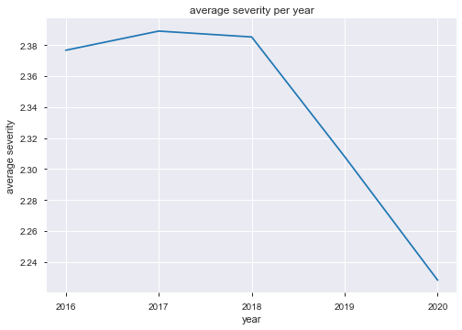

Fig 2. Mean severity per year

An important facet of this study is *when* do collisions take place. Fortunately, each recorded collision has a start and end time associated with it. This allows the deduction of a large amount of useful data which is not immediately apparent. For instance, the month and exact day of the week can be extracted from the basic data provided.

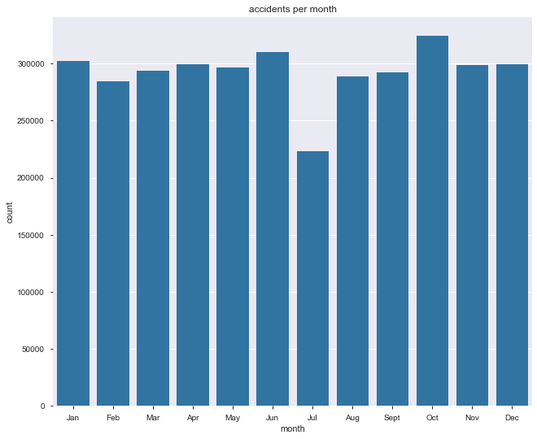

Fig 3. Accidents in each month

The first metric of interest is the month in which collisions occur. Each month of the year displays approximately the same number of collisions over the four years studied. The only difference is a significant decrease on occurrences in July. Once again, several hypotheses have been suggested, but more data is required in order to make a conclusive decision.

The most likely hypothesis is that perhaps the reduction in traffic going to school in the mornings results in a decrease in collisions, as well. A decrease in traffic volume naturally leads to a reduction in car accidents occurring. This is elaborated upon further later in the study. July is typically when summer vacation starts for schools in the United States. This then results in the reduction of traffic which leads to a reduction in accidents.

Another hypothesis involves people traveling by air and leaving the country for their vacations or not using vehicles as all locations of their vacation are within easy walking distance. This is somewhat plausible, however, there is no data within the current dataset which would be able to support this with evidence. Since the first hypothesis has more evidence to support it, it is the most likely to be true.

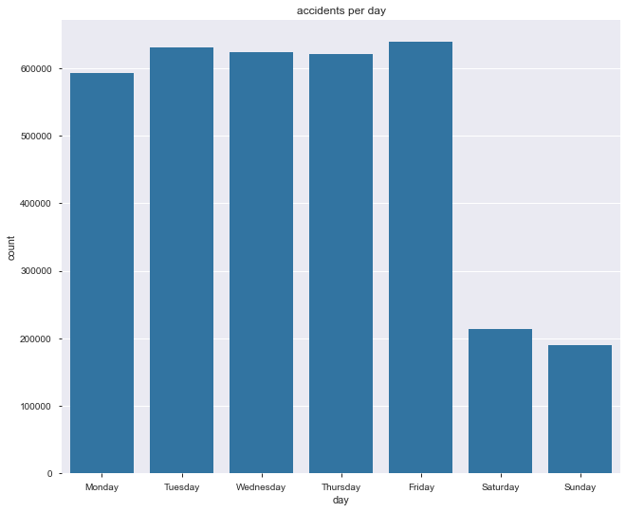

Fig 4. Accidents per day

The next variable of interest is the day of the week on which an accident has occurred. This data is not directly available, but it was acquired from the date which of each accident. An interesting pattern develops when this data is used to produce a figure. As seen in Figure 3, the vast majority of collisions occur during the work week; only a few accidents take place on the weekend. In fact, this pattern makes perfect sense. Collisions would occur more frequently on days which traffic volume is high. Whereas, on the weekends, traffic volume is lower since the majority of people will not be travelling to and from work. This pattern is further validated by the pattern shown in Figure 5.

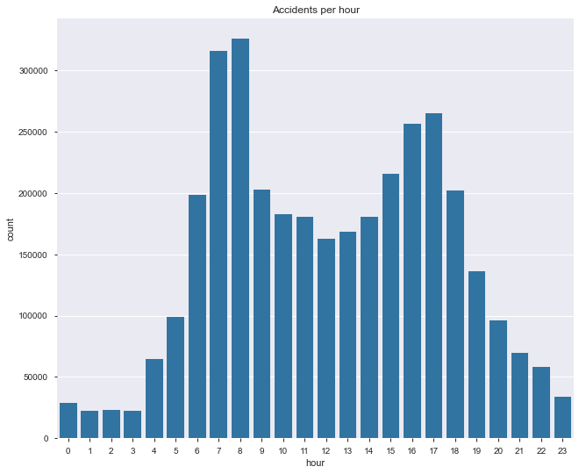

Fig 5. Distribution of accidents in each hour

Figure five depicts the distribution of accidents which occur in each hour of the day. Once again another interesting, yet perfectly sensible, pattern emerges. There are two large spikes in accidents twice in any given day. The first is at seven and eight o’clock in the morning. The other occurs between four and 5 o’clock in the afternoon. The depicted pattern once again suggests that traffic volume is a large contributor to the number of accidents which occur. The large spikes through the day correspond to rush hour. These are the times of day when a large percentage of the population is travelling either to work or school and then back home in the afternoon. In fact, these four hours account for more than one-third of all the accidents recorded by the study. That is, more than one million out of the total of three million collisions were recorded to occur in only these four hours of the day. This, once again, suggests that traffic volume is a large contributor to a collision occurring.

In addition, this pattern further supports the hypothesis that July experiences such a large decrease in collisions occurring because school traffic has been reduced. Children not being dropped off and college students not commuting to campus would both reduce traffic volume. However, it should be noted that it is also possible that traffic volume is reduced due to people traveling on air planes, as well. Since the majority of students are off from school, families are traveling on vacations together. Therefore, traffic volume is further reduced from adults traveling as well which reduces traffic volume during that month.

At this point, the question of accident severity becomes apparent. It has been seen that traffic volume may be a factor in an accident occurring. However, is the same true for the severity of an automobile collision? Through the investigation of the available data, a pattern can be found which helps to show a correlation between traffic volume and severity.

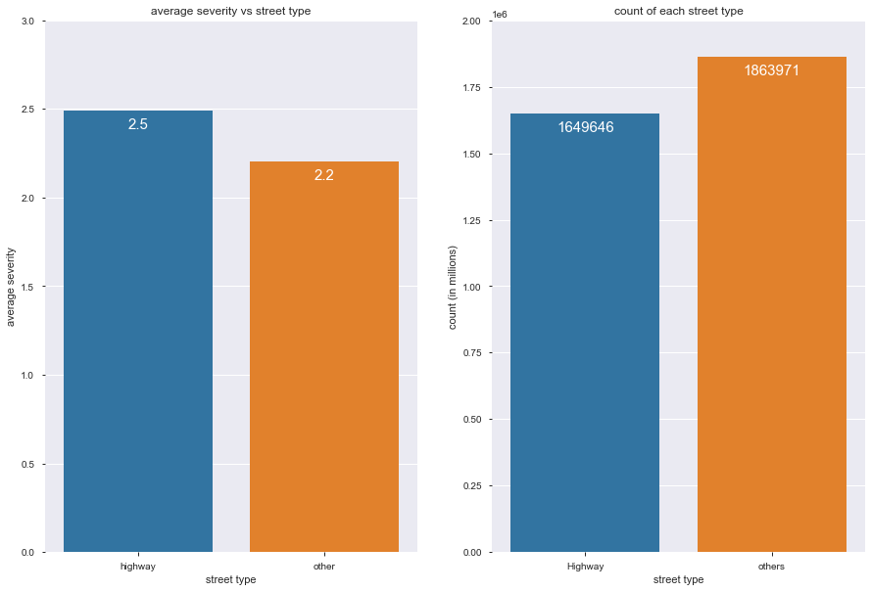

Fig 6-A. Mean severity vs street type

Fig 6-B. Count of each street type

Once again, the street type of each collision was not directly available; however, it was easily obtained due to the name of the street on which each collision occurred. In the United States, the vast majority of streets are recognizable based on their name. For instance, highways are almost always denoted by the prefix ‘I-‘ or the prefix ‘US-.’ Surface streets follow a similar pattern of their own. Therefore, given these conventions, it is easy to deduce the street type with a very high accuracy. Since the occurrence of surface streets is very high, the street types were distributed between two classes: Highways and other. Highways denote interstates, highways, and other major, high speed, high volume roadways. The ‘other’ class contains all surface streets and those roadways which are not high speed in nature.

Once each street was classified into a street type, the mean severity was calculated for each street type. The count of occurrences was also calculated for both classes. Upon generating a figure with this data, a pattern is seen.

Figure 6-A shows the mean severity for both street types, highways and others/surface; Figure 6-B, on the other hand, simply shows the total times a collision has occurred on each type of roadway. When compared, it is noticed that highways have a severity which is 7.5% higher than the mean severity seen on the other category. At the same time, Figure 6-B shows that highways have a lower number collisions occur on them. Specifically, surface streets appear 6.10% more often than highways. This once again suggests that traffic volume and the occurrence of a collision are correlated. However, it also suggests that speed may also influence an accident happening. Severity of an accident is lower on surface streets; which typically have a maximum speed of 45 miles per hour. On the contrary, highways have a standard speed of 70 miles per hour and have a higher mean severity, as well. Unfortunately, the speed at which an accident occurred is not directly available. Therefore, it must be deduced from the data which is available, similar to street types and the days of the week each collision occurred on. However, these are common norms and, therefore, quite reliable with only minor fluctuations.

It appears that speed is a factor in determining the severity of a collision. However, it is a common saying that freezing conditions cause more severe accidents. Luckily, the data has temperature data available directly. From this, temperature and severity can be studied easily.

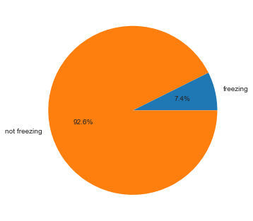

Fig 7. Proportion of freezing and non-freezing temperatures

Figure 7 shows the proportion of accidents which occur during freezing and non-freezing temperatures. It is very clear that the vast majority accidents occur during non-freezing temperatures. This may be because people avoid traveling extensively during freezing temperatures due to the common knowledge that is much more dangerous than non-freezing temperatures.

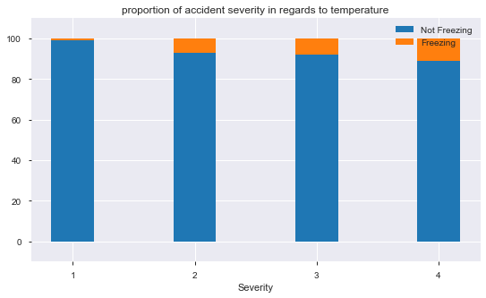

Fig 8. Proportion of severity in freezing and non-freezing temperatures

Figure eight depicts the proportion of each severity class which occurs during freezing and non-freezing temperatures. As severity increases, the proportion of accidents occurring during freezing temperatures increases, as well. This implies that temperature does, in fact, have an influence on the severity of accidents. However, it should be noted that temperature has a lower Pearson r score than location, which is also correlated with speed and street type.

Top 10 Cities

An interesting path of exploring the dataset was the fact that only ten cities constituted between 16% to 19% of all accidents which occurred in the United States. At first glance, these cities do not have very much in common. They are in different parts of the country, have wildly different populations, and only a few have national significance.

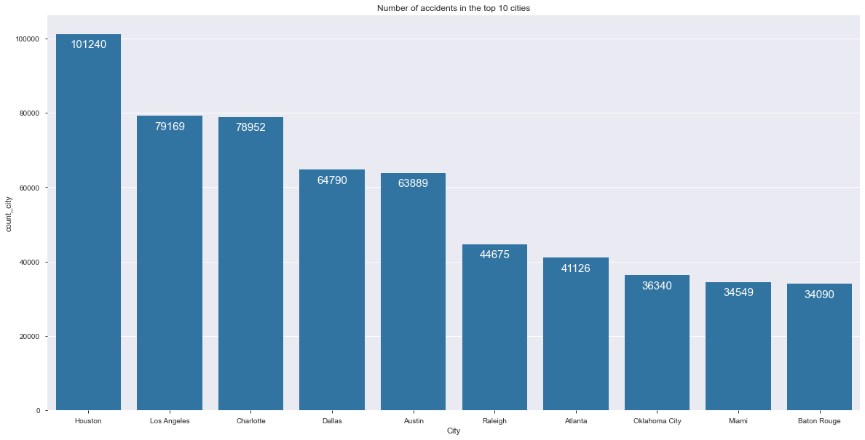

Fig 9. Top 10 cities with the most accidents

Figure nine shows the top ten cities which have the most accidents in the United States. As can be seen, only two of these receive large amount of non-local traffic: Los Angeles and Miami. Atlanta, Dallas, and Houston are airline hubs which receive large amounts of air traffic, but most people do not actually leave the airport. Instead, they transfer to another flight to their final destination.

Unfortunately, charting the properties of these ten cities does not reveal any obvious pattern as to why they have such a high number of accidents. For instance, Figure 10 shows the mean delay caused by accidents in each of these cities.

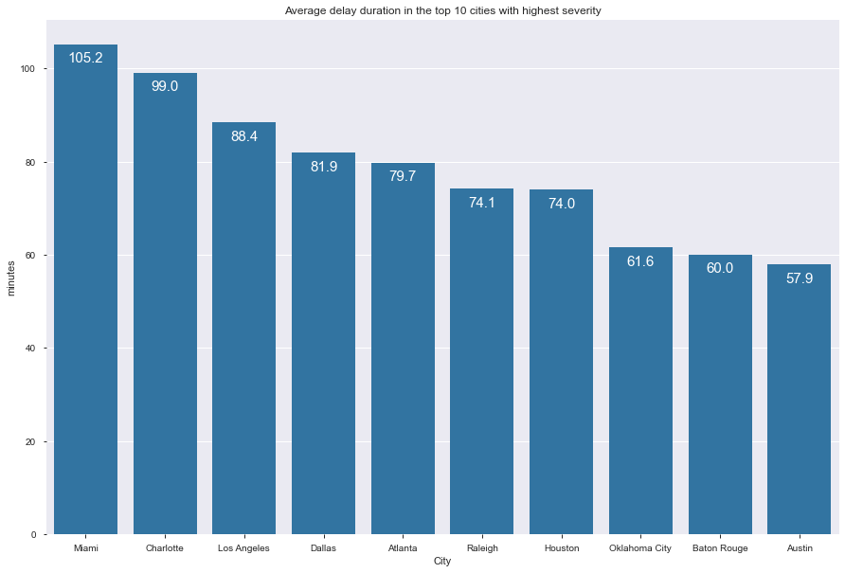

Fig 10. Mean delay in top 10 cities

The delays in each city vary greatly. Miami has an average delay 105 minutes or one hour and forty-five minutes; whereas, Austin has a much lower average delay of only about 58 minutes. Unfortunately, this does not show any obvious patterns regarding these cities.

Machine Learning: Clustering

Perhaps machine learning will be of use to detect a pattern not clearly visible from exploring the data. Unsupervised machine learning is used in order to cluster accidents together for each of these 10 cities. In addition, a heat map is applied in order to further refine the clusters and provide a clearer understanding of where collisions are occurring the most.

An interesting pattern emerges from this technique which helps to explain not only the similarity between these ten cities but also helps to answer questions raised during the exploratory phase of the study. As only a few heatmaps will be studied in depth, all of them will be available in the supplementary data at the end of the study.

The heatmaps of Dallas, Los Angeles, and Houston will be studied and will help to clarify questions raised earlier.

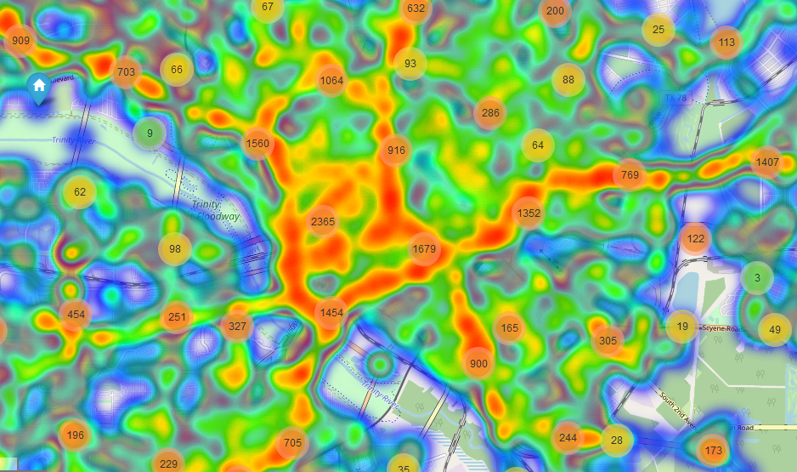

Map 1. Dallas, TX

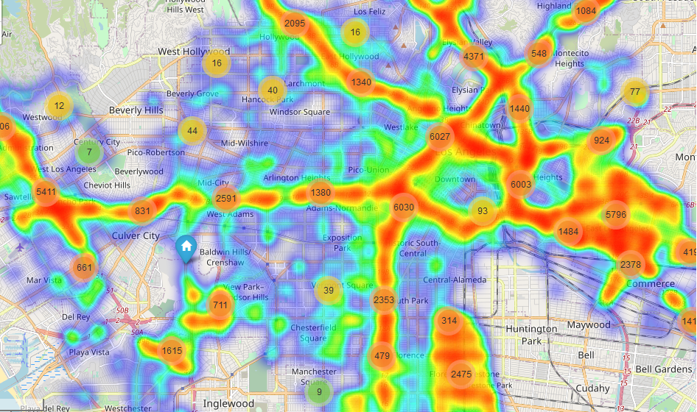Po

**A**

**C**

**B**

Map 2. Los Angeles, CA

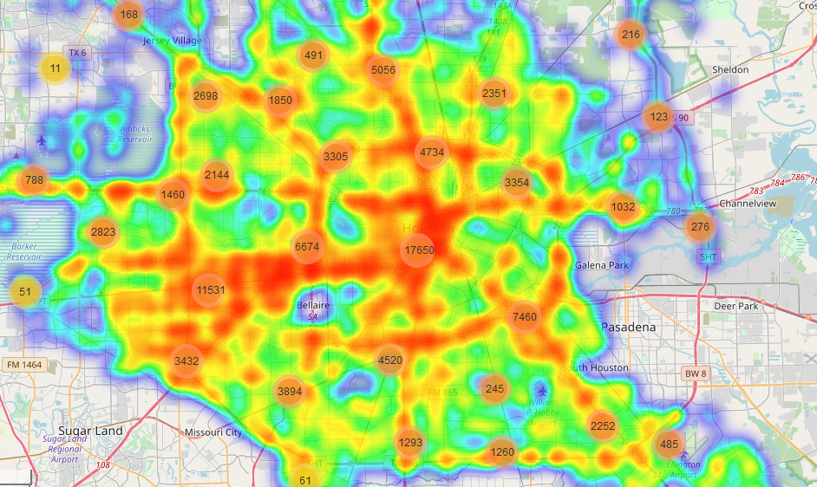

**E**

**D**

Map 3. Houston, TX

Studying these maps almost immediately shows a relationship which was only hinted at by data exploration. All of these cities have large numbers of highways. As can be seen, very large clusters are seen following the rough paths highways take through the city. Upon further refinement with a heatmap, a remarkable pattern appears. The densest areas of the clusters follow the exact path of the highway associated with them. Take, for example, Los Angeles in Map 2. An almost perfectly lines of red are seen following highways throughout the city.

However, this analysis reveals another pattern which was not seen at all in data exploration. Junctions appear to be particularly prone to very dense clusters of accidents occurring. Consider the map of Los Angeles presented above (Map 2). Three points have been denoted which have very dense clusters: points A, B, and C. At each of these locations, junctions between highways can be seen along with several very dense clusters. At point A, a cluster is seen composed of more than 4,300 collisions. In additions, there are two smaller clusters in the outlaying area which contribute to the density at the junction, as well. Point B shows a similar effect taking place. A dense cluster of more than 5,000 collisions is present; most of which lie on the highways and the junction itself. Point C, however, displays the best demonstration of the findings. A rough square can be seen following the highways which form it. However, at all of the major junctions at Point C, very large clusters are seen; each of which has more than 6,000 collisions. In total, the area of Point C is the location of more than 18,000 collisions over the course of 2016 to 2020. What else is remarkable about this specific location, is that in the center of the square, where surface streets are, the density of collisions is very low. In fact, it appears to be almost zero in some areas.

This pattern is once again seen in Houston, Tx (Map 3). Houston is known for a two rings of highways surrounding it with branches going into the city itself. Once again, the dense red areas of the heatmap follow the highways throughout the entire city. However, one area stands out from the rest. Point D, which is at the center of the city, exhibits an extremely large and dense cluster of more than 17,000 collisions. Of interest is the fact that this is the location where many branches and highways all converge. The ring surrounding the center shows several other dense clusters of more than 4,000 collisions. Of further interest is Point E. This location once again demonstrates the confluence of highways, as well as a dense cluster of more than 11,000 accidents. The same pattern is found in all ten of the heatmaps generated for the top 10 cities. This analysis has made clear that the location, speed, and street type all have a high correlation with an accident occurring. In fact, upon performing a Pearson correlation test, a fairly high correlation is returned.

Machine Learning: Prediction

Given the discoveries made thus far from the dataset, it is natural to question whether the severity of an accident can be predicted. To achieve this goal, machine learning will once again be utilized. Although, for this task, supervised learning will be used to train models and make predictions. Several models will be evaluated and rated by accuracy score. These include K-NearestNeighbors (KNN), Random Forests, and Single Vector Machines (SVM).

Originally, the models were trained using all four classes available for severity and several variables. This returned subpar results for all models, and SVM was unable to run properly due to hardware limitations. To rectify this, the most important variables were identified, which resulted in variables being narrowed down to only location. All of the models were trained once again with all four classes of severity and only the location data for each collision. Once again, Random Forest returned subpar results with SVM unable to execute fully. However, KNN returned an accuracy score of approximately 83%.

Following this, another method was attempted. Due to a class imbalance (shown in figure 11) the data was separated into two super-classes.

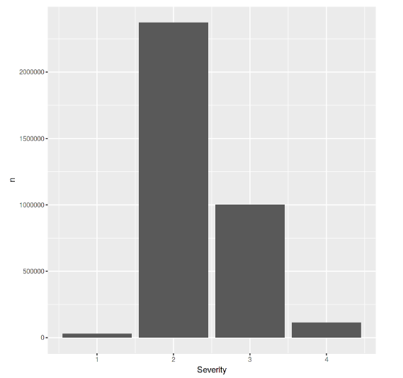

Fig 11. Class imbalance among severity data

As seen in Figure 11, the majority of accidents have a severity of either two or three, with two having the most occurrences. Therefore, the classes were divided into two super-classes: high severity and low severity. All three models were attempted once again with similar results. SVM, once again, was unable to execute fully due to hardware limitations, and Random Forest returned subpar results. KNN, on the other hand, experienced a small increase in accuracy. This is most likely due to the model being able to train properly for all cases rather than having two classes be very small and unable to be trained properly. Figures 12 and 13 display the results of KNN prediction for several values of ‘k.’

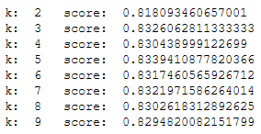 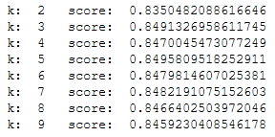

Fig 12. KNN with all 4 available classes. Fig.13. KNN with 2 super classes

Conclusions

Following this study, several findings can be conclusively described. The first involves the factors involved in a collision. While it is true that temperature, time of day, and weather all influence the possibility of a collision, the most important factors are street type, location, and speed. In the case of this study, speed and street type are both highly correlated with location. This can be determined by Pearson R coefficient. In addition, the accuracy of predictive models was significantly better when predictions were made using only location data. Increased variables only served to reduce accuracy drastically.

Clustering revealed that collisions appear to follow areas which display high traffic volume. This includes highly travelled roads and highways. Specifically, highways showed high densities of collisions occurrences compared to surface streets in the same area (see heatmaps). In addition, clustering was able to show that highway junctions are particularly susceptible to collisions. In each studied city, junctions showed much denser clusters than were seen in other areas of highway.

Sources

Data source: <https://www.kaggle.com/sobhanmoosavi/us-accidents>

Heatmaps

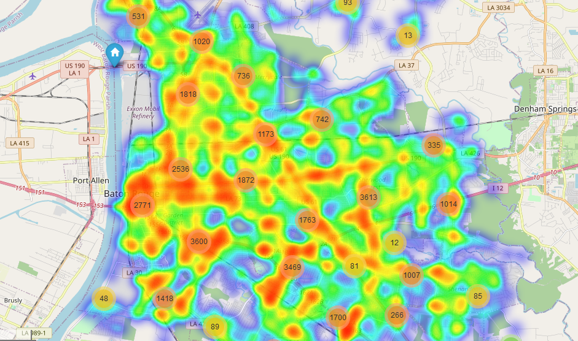

Baton Rouge, LA

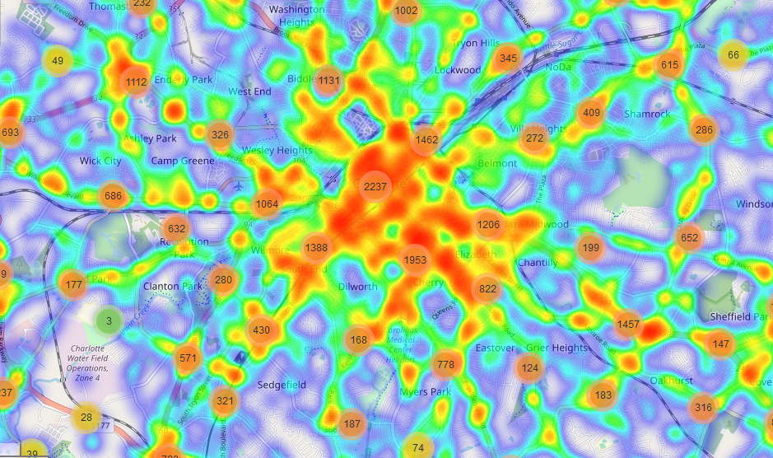

Charlotte, NC



Dallas, TX



Houston, TX



Los Angeles, CA

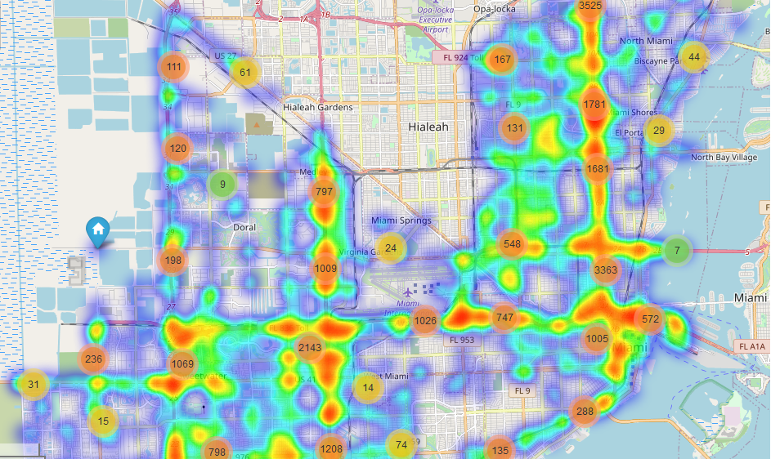

Miami, FL

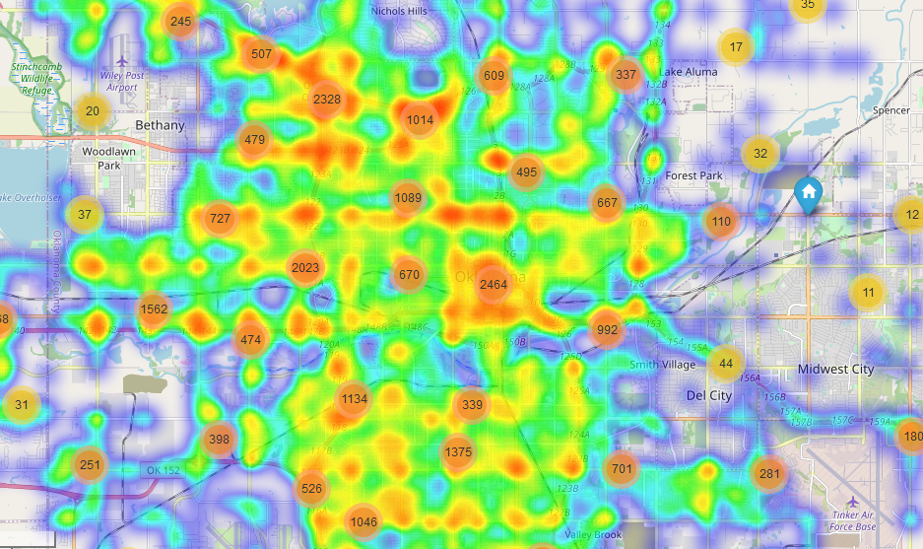

Oklahoma City, OK

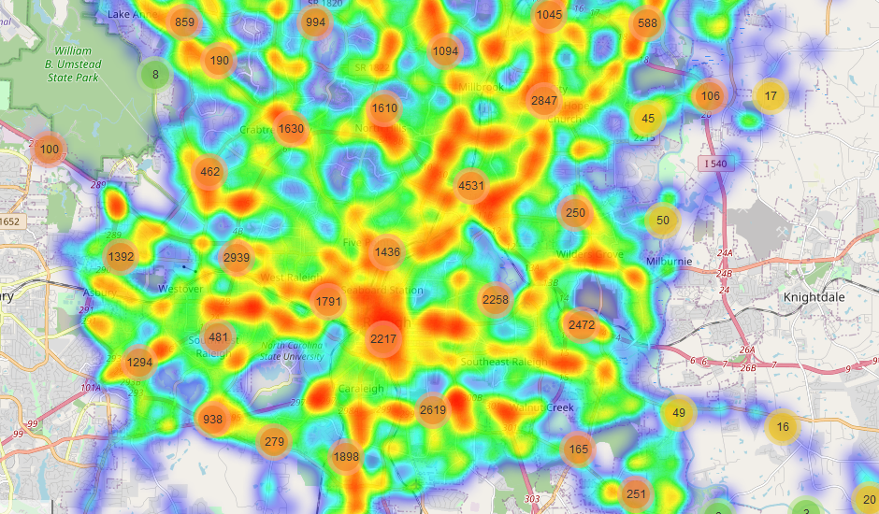

Raleigh, NC